**Project Report: IR-Based Door Security Alarm System**

**Introduction**

This project aims to develop a simple, low-cost IR-based door security alarm system using basic electronic components and PCB fabrication techniques. The system detects any object or person approaching the door and triggers an alarm (buzzer).

**Objective**

To design and implement an IR-based intrusion detection system on a custom-designed PCB using the LM358 operational amplifier and basic IR components.

**Components Used**

| **Component** | **Description** |
| --- | --- |
| LM358 IC | Dual operational amplifier used for signal comparison. |
| IR Transmitter (LED) | Emits infrared light towards the IR receiver. |
| IR Receiver (Photodiode) | Detects the IR light and converts it into an electrical signal. |
| 100Ω Resistor | Limits current to the IR transmitter. |
| 10kΩ Potentiometer (VR) | Adjusts the sensitivity of the IR receiver circuit. |
| 220Ω Resistor | Limits current to the output LED/buzzer. |
| LED | Indicates the working status of the circuit. |
| Buzzer | Produces sound alert when triggered. |
| 9V Battery | Powers the circuit. |

**Block Diagram**

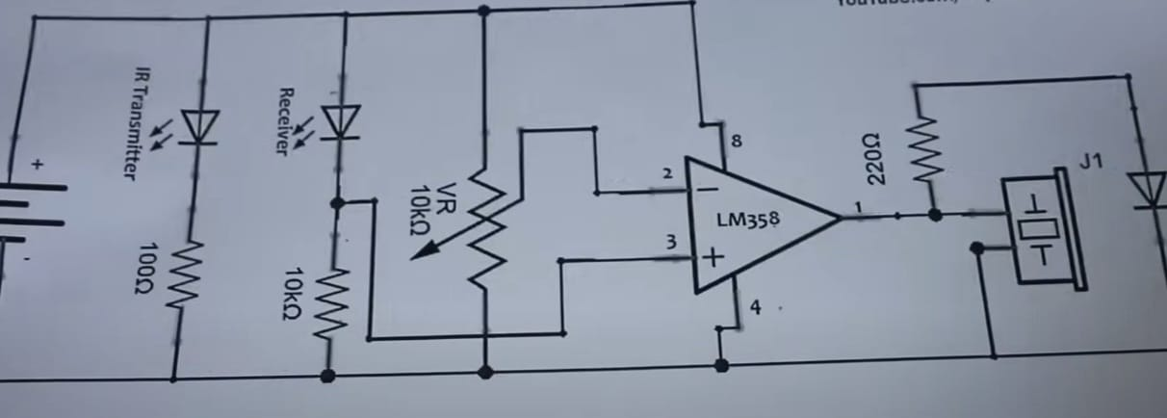

**Circuit Diagram**

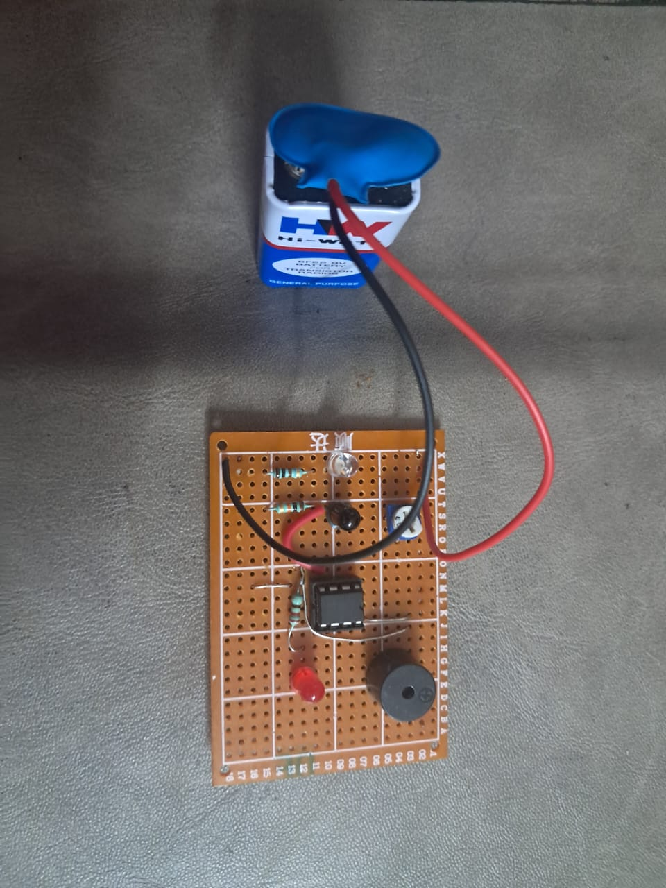

**PCB Design and Fabrication**

* The circuit was designed on a copper-clad PCB board.
* Components were carefully soldered using a soldering machine.
* The connections were made according to the designed circuit schematic.
* The tracks were etched properly and verified before component placement.

**Working Principle**

* The IR transmitter constantly emits infrared light.
* When an object or person interrupts the IR beam, the IR receiver detects the reflected IR light.
* The LM358 op-amp acts as a comparator and compares the receiver output with a preset threshold set by the potentiometer.
* If the threshold is exceeded, the op-amp outputs a high signal, activating the buzzer and LED to indicate intrusion detection.